# GPS trajectory data(Using 5 sets)

MySql

**Storing Data**

We store each measure as a row into a table Trajectory, the table’s structure is like following,

*CREATE TABLE Trajectory (*

*SetId char(5) not NULL,*

*TrajectoryID char(15) not NULL,*

*lat double(12,8),*

*lon double(12,8),*

*alt int(6),*

*datenum double(18,11),*

*date char(11),*

*time char(10) )*

**Querying Date**

1. Count the number of GPS points in the trajectory.

Return the count of rows whose *"*SetID*"* equals provided setid and *"*TrajectoryID*"* equals defined trajectoryid

1. Select 10 different days, and for each day, find the number of GPS points that were measured on that day.

Return the count of rows whose "date" equals provided date

**Time consumption**

|  |  |  |  |  |  |
| --- | --- | --- | --- | --- | --- |
| Case/  Time(ns) | 1 | 2 | 3 | 4 | 5 |
| Insert into DB | 351103803868 | 341706028960 | 344096003484 | 342370189447 | 337376933776 |
| Count number | 587446023 | 578168005 | 607320547 | 602797468 | 610619868 |
| Count date | 4802387067 | 479220113 | 4956240568 | 4921631698 | 4961183987 |

Document store: MongoDB

**Storing Data**

We store each measure as a document into MongoDB, the structure is like following,

*{ "_id" : ObjectId("547418f1300452579430025f"), "TrajectorySetID" : "000", "TrajectoryID" : "20081023025304", "Latitude" : 39.98447, "Longtitude" : 116.308827, "Altitude" : 257, "Date" : 39744.1236111111 }*

**Querying Date**

1. Count the number of GPS points in the trajectory.

Return the count of documents whose *"*TrajectorySetID*"* equals provided setid and *"*TrajectoryID*"* equals defined trajectoryid

1. Select 10 different days, and for each day, find the number of GPS points that were measured on that day.

Return the count of documents whose "Date" equals provided date

**Time consumption**

|  |  |  |  |  |  |
| --- | --- | --- | --- | --- | --- |
| Case/  Time(ns) | 1 | 2 | 3 | 4 | 5 |
| Insert into DB | 127641202966 | 125697966882 | 125222846892 | 129169023263 | 129743884644 |
| Count number | 45530692 | 47120451 | 48060204 | 46763818 | 47586373 |
| Count date | 5989851636 | 6190969990 | 6161586115 | 6187229852 | 6232348071 |

Key-value: Redis

**Storing Data**

We store each Trajectory as a list(SetID+TrajectoryID as key) into Redis, and each measure is an element of a list, the structure is like following,

*Key: “00020081023025304”*

*Data: {“40.002684,116.323946,959,39986.4128703704,2009-06-22,09:54:32”}, {“40,116.325545,105,39986.4131597222,2009-06-22,09:54:57”}, ...*

**Querying Date**

1. Count the number of GPS points in the trajectory.

Return the size of the list whose Key equals provided setid + trajectoryid

1. Select 10 different days, and for each day, find the number of GPS points that were measured on that day.

Implemented by two loops, first traverse all lists, and then traverse all measures in the list. In each measure check if the date filed equals provided date, if yes, count++.

**Time consumption**

|  |  |  |  |  |  |
| --- | --- | --- | --- | --- | --- |
| Case/  Time(ns) | 1 | 2 | 3 | 4 | 5 |
| Insert into DB | 50121956950 | 51083670161 | 51190599183 | 50121956950 | 50488010953 |
| Count number | 24426743 | 24017282 | 26549638 | 23873036 | 27185598 |
| Count date | 9292069671 | 9252741494 | 9328643413 | 9279856441 | 9456104037 |

Comparison

# 

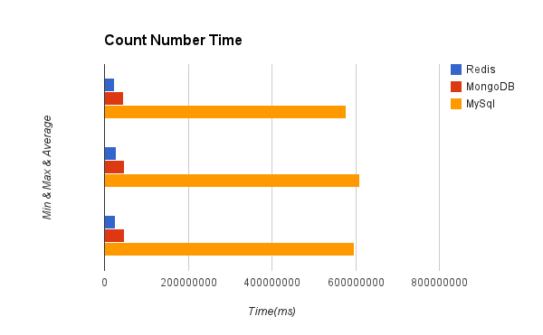

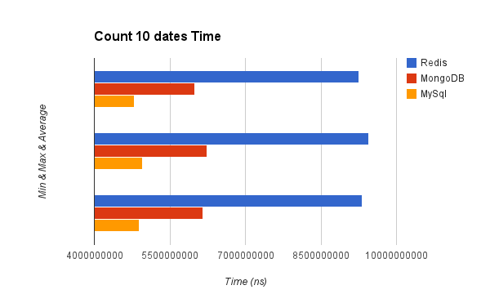  
  
Summary:

1. Create DB speed: Redis>MongoDb>MySql

2. When using Redis to query count of 10 days, we have to use two loops to traverse all measures, so it’s the slowest one.

3. When using select count(*) from X in mysql, it’s slow

# Graph data (Facebook-combined)

Graph DBMS: Neo4j

**Storing Data**

The whole dataset is stored as a graph in neo4j. Each point in dataset is stored as a node, and each line (an edge between two points) is stored as a relationship.

**Querying Date**

We use Traverser to query data. In NeighbourCount function, we set search method as breadthFirst, set relationship direction as outgoing, and set terminate evaluator as no more new nodes being added. In ReachabilityCount function, we set search method as breadthFirst, set relationship direction as outgoing, and set terminate evaluator as where last relationship type is “connects” (pruneWhereLastRelationshipTypeIs(RelTypes.CONNECTS)), which guarantees that only the nodes directly linked with startNode can be added.

**Time consumption**

|  |  |  |  |  |
| --- | --- | --- | --- | --- |
| Case/Time(ms) | 1 | 2 | 3 | 4 |
| Insert into DB | 6482 | 6389 | 6779 | 6505 |
| Count Neighbour | 163 | 194 | 221 | 161 |
| Count Reachablility | 1907 | 1856 | 173 | 157 |

MySQL

**Time consumption**

|  |  |  |  |  |
| --- | --- | --- | --- | --- |
| Case/  Time(ms) | 1 | 2 | 3 | 4 |
| Insert into DB | 219479 | 210714 | 207847 | 212814 |
| Count Neighbour | 55 | 47 | 101 | 49 |
| Count Reachablility | 193098 | 188742 | 299 | 52 |

Comparison

CreateDB:

|  |  |  |  |
| --- | --- | --- | --- |
|  | minimal time | maximal time | average time |
| MySQL | 207847 | 219479 | 213663 |
| Neo4j | 6389 | 7171 | 6447 |

*Neighbour count*:

|  |  |  |  |
| --- | --- | --- | --- |
|  | minimal time | maximal time | average time |
| MySQL | 47 | 101 | 74 |
| Neo4j | 158 | 221 | 190 |

*Reachability count* :

|  |  |  |  |
| --- | --- | --- | --- |
|  | minimal time | maximal time | average time |
| MySQL | 52 | 193098 | 96575 |
| Neo4j | 152 | 2075 | 1113 |

Summary: We can conclude that, with enough complexity of the graph dataset, the performance of CreateDB and Reachability Count on Neo4j is much better than on MySQL, and the difference between the performance of Neighbour Count on Neo4j and on MySQL is pretty small. So the whole performance of Neo4j is much better than MySQL on Graph data, especially there are huge amount of edges and nodes in graph dataset.